Productive Vocabulary

🗣️ What is Productive Vocabulary
# Source: AI Source: Provided by: [Data Path: Persons Table -> ID Column: 1, Name_En Column: Motasem Essam] -> From: [Chatgpt (GPT-4-turbo)] on [7/30/2025]
Productive vocabulary refers to the words a person can actively use in speaking and writing. These words are not only understood but also correctly produced in communication.

✅ Key Features:
# Source: AI Source: Provided by: [Data Path: Persons Table -> ID Column: 1, Name_En Column: Motasem Essam] -> From: [Chatgpt (GPT-4-turbo)] on [7/30/2025]
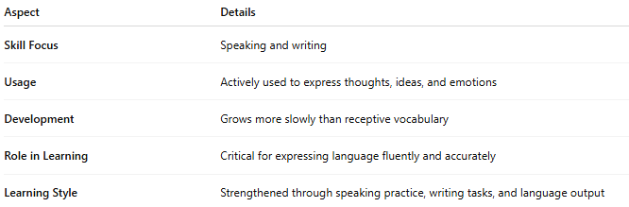
Aspect | Details
Skill Focus | Speaking and writing
Usage | Actively used to express thoughts, ideas, and emotions
Development | Grows more slowly than receptive vocabulary
Role in Learning | Critical for expressing language fluently and accurately
Learning Style | Strengthened through speaking practice, writing tasks, and language output

🧠 Example:
# Source: AI Source: Provided by: [Data Path: Persons Table -> ID Column: 1, Name_En Column: Motasem Essam] -> From: [Chatgpt (GPT-4-turbo)] on [7/30/2025]
- A student writes the sentence: “She made a cautious decision.”
👉 This shows active use of the word “cautious” in context

👤 Who Uses It?
# Source: AI Source: Provided by: [Data Path: Persons Table -> ID Column: 1, Name_En Column: Motasem Essam] -> From: [Chatgpt (GPT-4-turbo)] on [7/30/2025]
- All speakers and writers, especially:
  - Fluent speakers
  - Writers and professionals
  - Language learners aiming for fluency
  - Students in academic or formal settings

🔄 Receptive vs Productive Vocabulary
# Source: AI Source: Provided by: [Data Path: Persons Table -> ID Column: 1, Name_En Column: Motasem Essam] -> From: [Chatgpt (GPT-4-turbo)] on [7/30/2025]
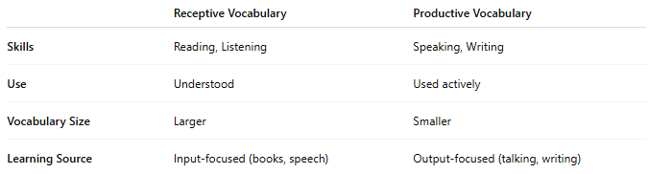
 | Receptive Vocabulary | Productive Vocabulary
Skills | Reading, Listening | Speaking, Writing
Use | Understood | Used actively
Vocabulary Size | Larger | Smaller
Learning Source | Input-focused (books, speech) | Output-focused (talking, writing)

